
Update Set
Mover
Application

Development Document

Developed and created by Pedro Leite
Select Information Classification © Fujitsu 2022
Contents
1. Overview 5
1.1 Purpose of Document 5
1.2 Resume of the Application 5
2. Important Notes 6
3. Global Scope 7
3.1 Script Include 7
3.1.1 UpdateSetAjaxGlobal 7
3.2 Choices 7
3.2.1 Pending Completion on this instance 7
3.3 Dictionary 7
3.3.1 Completed on Prod 7
3.3.2 Ready to move to prod 7
3.4 Client Script 7
3.4.1 Show options if US is committed on Prod 7
3.4.2 Update Set Mover State Options 8
3.5 UI Action 8
3.5.1 Mark Update Sets As Ready to Go to Prod 8
4. Application Scope 9
4.1 Modules 9
4.1.1 Application Properties 9
4.1.2 Instances Configurations 9
4.1.3 Ready to Move to Prod 9
4.1.4 Update Set State Histories 9
4.1.5 USM – Business Rules 9
4.1.6 USM – Script Include 9
4.1.7 USM – Client Script 9
4.2 System Activation 9
4.3 Tables 10
4.3.1 Instances 10
4.3.2 Update Set State History 11
4.4 Business Rules 11
4.4.1 If committed on Prod update last instanc 11
4.4.2 Turn On / Off the Whole Application 11
4.4.3 Commit Update Set Log to History 12
4.4.4 Set States after Update Set is Committed 12
4.5 Script Include 12
4.5.1 updateSetMoverUtils 12
4.6 Roles 12
4.6.1 Instance Configuration table 12
4.6.2 12
4.6.3 Out of Box Admin Role 12
4.6.4 instances_user 12
4.6.5 update_set_state_history_user 12
4.6.6 update_set_mover_admin 13
4.7 System Properties 13
4.7.1 userID 13
4.7.2 password 13
4.7.3 get_instance_name 13
4.7.4 Application Switch On/Off 13
4.8 Inbound Integrations 13
4.8.1 Scripted REST APIs 13
4.8.1.1 Remove Flag from Committed Update Sets 13
4.8.2 Scripted REST Resource 13

Overview

Purpose of Document
The purpose of the document is to highlight the development work of the Update Set Mover Application.
This document has an explanation about each record that makes the whole application work, but it doesn’t show any scripts whatsoever, only the purpose, in a resume, of the scripts, purpose, logic and functionalities.

Resume of the Application
It’s a simple application that:
- Allows an extra layer of approval for the Update Set to go to Production and
- Records all the operations on a table called “Update Set Mover History”

This will allow to:
- Reduce “update set” pollution on production
- More control on what goes to production and have a better way to track who created, pulled, committed, or backed out the updates sets on all instances where this is installed

It is also possible to create reports based on the “Update Set Mover History”

Important Notes
For this application to work, there must be a remote instance configuration already in place, at least two instance, Development and Production instance.
The following graphic illustrates how everything works in theory.
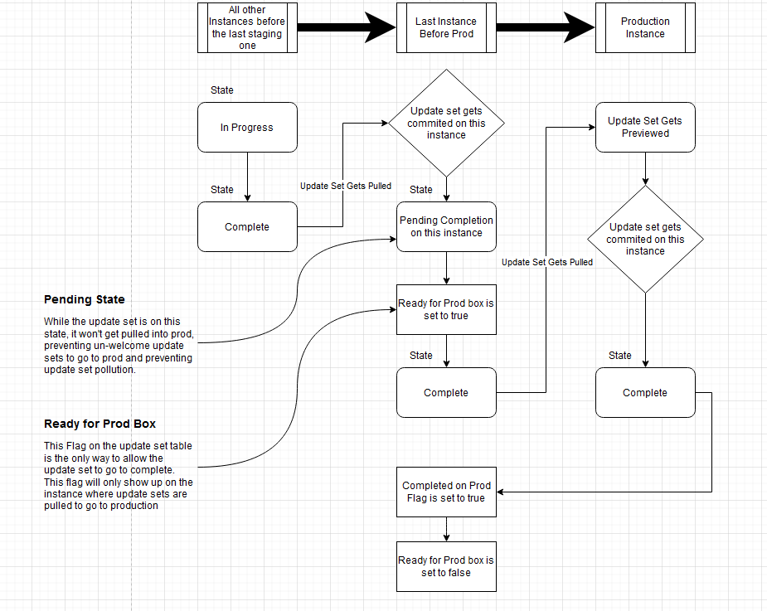

This application is divided into two pieces, the global update set and the application scope update set.
The Global update set contains a Script include that it will be the bridge between Global and Application Scope.
This was split due to access restriction to the sys_update_set table outside of the global scope.

Always make sure you’re in the correct scope while doing stuff on the application, for example, if you need to turn on/off the whole application in the application properties, you must be on the application scope.

Global Scope
These records are generated from a specific script on global scope, but it’s called from the application scope.

Script Include

UpdateSetAjaxGlobal
Various ajax functions for update sets from Update Set Mover application.
It contains various methods such as:
- setUpdateSetStateAfterCommitted sets the update set to “Pending Completion on this instance” after the update set is committed.
- buildRecords builds records after the application is turned on.
- deleteRecords deletes the records that were created after the application is turned on.
- setReadyForProdFalseGlobal Sets the flag “ready for prod?” to false after being committed on prod on the current instance (if this is the one before production and configured on the Instances table).
- checkIfLastInstanceBeforeProd checks if the current instance is the last one before production.

It also has some methods that helps the connection between instances and allows the flag “Completed on prod” and “Ready to move to prod?” to be disable or enable automatically.
The methods to build and delete records, generate the records on 3.2, 3.3, 3.4 and 3.5.

Choices

Pending Completion on this instance
Label: “Pending Completion on this instance”
value: “pending”

Dictionary

Completed on Prod
Label: “Completed on Prod”
value: “u_completed_on_prod”

Ready to move to prod
Label: “Ready to move to prod?”
value: “u_ready_to_move_to_prod”

Client Script

Show options if US is committed on Prod
On Load and On Change Client script based on "Ready to move to prod?" field.

Update Set Mover State Options
Update Set Mover State Options depending on the instance options configurations from the Update Set Mover application.

UI Action

Mark Update Sets As Ready to Go to Prod
List view UI action that allows a bulk change of state to complete and set the flag “Ready to move to prod?” to true. This allows multiple Update Sets to be set simultaneously.
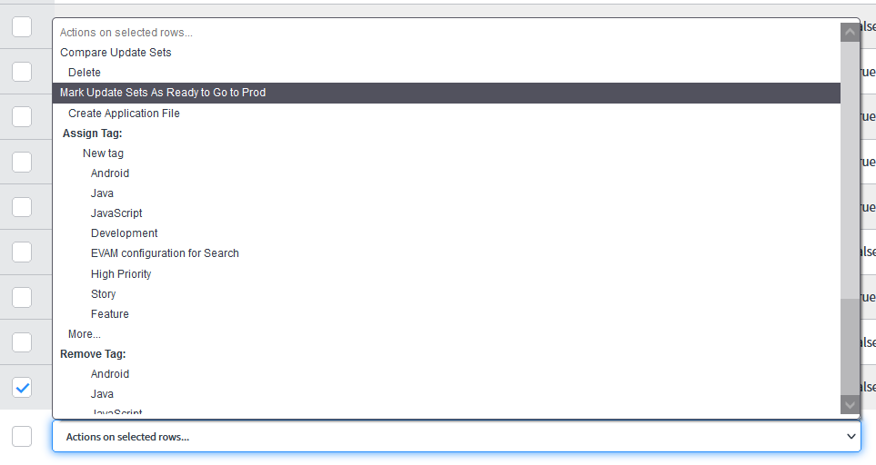

Application Scope
The application scope is where most of the application was built.

Modules

Application Properties
Core configurations to setup the Application, this has to be configured first before the application is used.

Instances Configurations
This is where we configure how the application will behave in each instance, it will be explained on 4.2.

Ready to Move to Prod
Shortcut to all update sets that have the flag “Ready to Move to Prod” set to true. This might help the developers or whoever needs to raise Changes for deployment.

Update Set State Histories
Update set state history table is where all the state updates of the update sets are stored.

USM – Business Rules
Shortcut to the Business Rules used by the application.

USM – Script Include
Shortcut to the Script Include used by the application.

USM – Client Script
Shortcut to the Client Scripts used by the application.

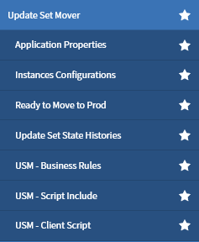

System Activation
This is a configuration record that has some core configurations of the application such as:
- User ID to make the REST call to update the state in the previous instance. This user ID must exist on the last instance before prod, so the update set can be updated via REST call.
- password to make the REST call to update the state in the previous instance
- This property allows you to turn ON or OFF the entire application. Write true or false.

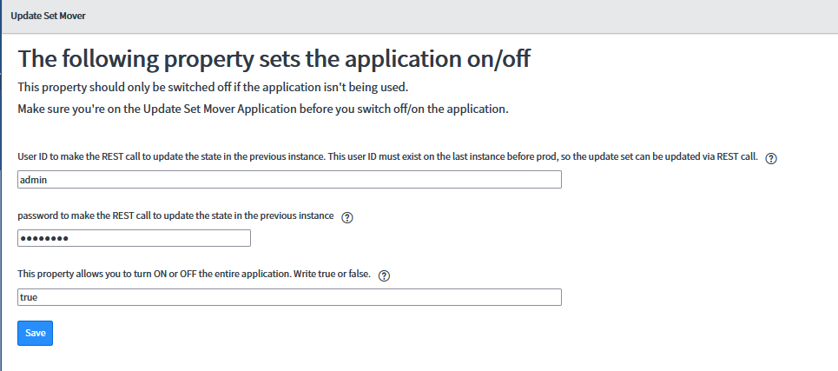

Tables

Instances
The table Instances (x_661539_update_0_instances) is where the Instances configurations are stored.
Each record stores the proper information for the whole application to work.
Fields and explanation:
Name: name of the instance
Order of instance: The lowest number should always be production, the next one should be the instance where update sets get pulled and the others should be the Development or other instances.
So, for example, on a client that uses Prod, Dev and Test, and where Test is the last instance before prod, the instances should be configured the following way -> Prod (100), Test (200) and Dev (300).
Type: Type of instance, it has 3 options, Production, Development and Test.
Update Sets Get Pulled to Prod from This instance?: Set this to true if the instance is the last one before production, which means, the update sets goes from here to production.
Record Example
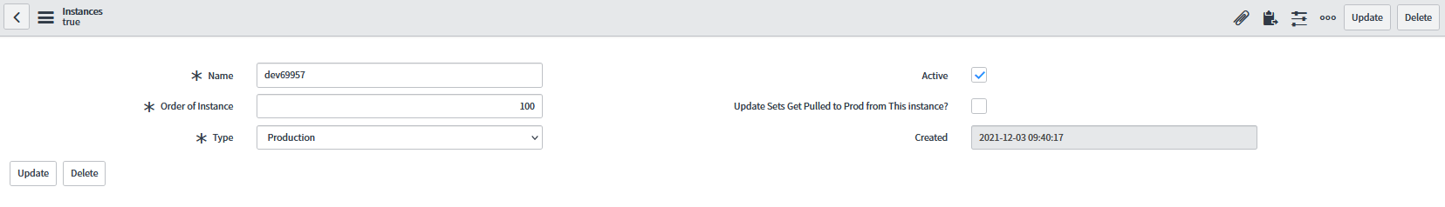

Update Set State History
This table records all the state changes applied to the update sets. This table is extremely important since it’s the one that triggers the update of the flag “Completed on Prod” and sets the “Ready to move to prod?” flag to false.
Fields and explanation:
Number: Record number
Update Set Name: Name of the target update set
Update set SysID: Original sysid of the update set. This value will be moved, as Out-of-Box, from instance to instance and it’s the value that allows the application to find the update set in all instances where it exists.
State: State
Updated From: Update source where this update set came from.
Updated by: Person that made the update to the update set.
Completed by: Person that completed the update set (in case the state was committed).
Description: Description of the update set.
Record Updated by: Person that updates the update set (in case the state wasn’t committed).
Current Instance Type: The type of the current instance.
Record Example
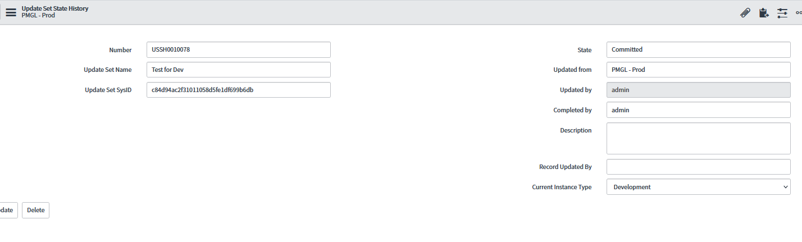

Business Rules

If committed on Prod update last instanc
This business rule is based on the Update Set State History table and, if the current instance is Production and the state of the record is “committed”, it makes a REST call to the previous instance, configured on the Instance table, search for the update set there and updates the flag “Completed on Prod” to true and sets the flag “Ready to move to prod?” to false.

Turn On / Off the Whole Application
Business rule responsible for listening when the flag “This property allows you to turn ON or OFF the entire application. Write true or false.” In the Application properties changes to true or false.
If true, turns the application on and creates the records described on point 3.1.1.

Commit Update Set Log to History
Business rule responsible to create a record on the Update set history table every time the state of the update set changes to Preview, committed, or backed out.

Set States after Update Set is Committed
Business rule responsible to set the state of the update set to “Pending Completion on this instance” if the instance is the last one before production and the update set was committed on that instance.
This business rule triggers on insert when the state is complete, and the remote sys id isn’t empty.
This situation only happens when an update set is retrieved, and it’s committed on that instance. This will make the update set to be inserted into the sys_update_set with a “Original sys_id” and a “Remote Sys Id”.

Script Include

updateSetMoverUtils
This script include has all the scripts that run on the server side of the application.
It contains various methods such as:
- getCurrentInstanceValue to get the current instance value from the Instances table.
- switchFunction to switch the application on/off.
- _buildOrDeleteGlobalRecords to tell the global script, based on if it’s to turn or not the application, to build or delete records into the global scope.
- _getPreviousInstance to check the information’s of the “previous” instance on the Instances table.
- updatePreviousInstanceState calls the method described in 4.8 that updates the flag “Ready for prod?” and “Completed on Prod” in the previous instance before production configured on the Instance table.
- setReadyForProdFalse Sets the flag “ready for prod?” to false after being committed on prod on the current instance (if this is the one before production and configured on the Instances table). Calls the method described in 3.1.1 on the global scope.
- _writeLog that works as a specific log tag to be easier to identify on the log table ([USM] + string)

Roles

Instance Configuration table

Out of Box Admin Role
Has access to everything.

instances_user
Has access to the Instance table with read and write access.

update_set_state_history_user
Has access to the Update Set State History with read permission.

update_set_mover_admin
Has access to the Instance table and the Update Set State History with read/write/create/delete permission.

System Properties

userID
User ID to make the REST call to update the state in the previous instance. This user ID must exist on the last instance before prod, so the update set can be updated via REST call.

password
Password to make the REST call to update the state in the previous instance

get_instance_name
Get current instance name

Application Switch On/Off
This property allows you to turn ON or OFF the entire application.
Write true or false.

Inbound Integrations

Scripted REST APIs

Remove Flag from Committed Update Sets
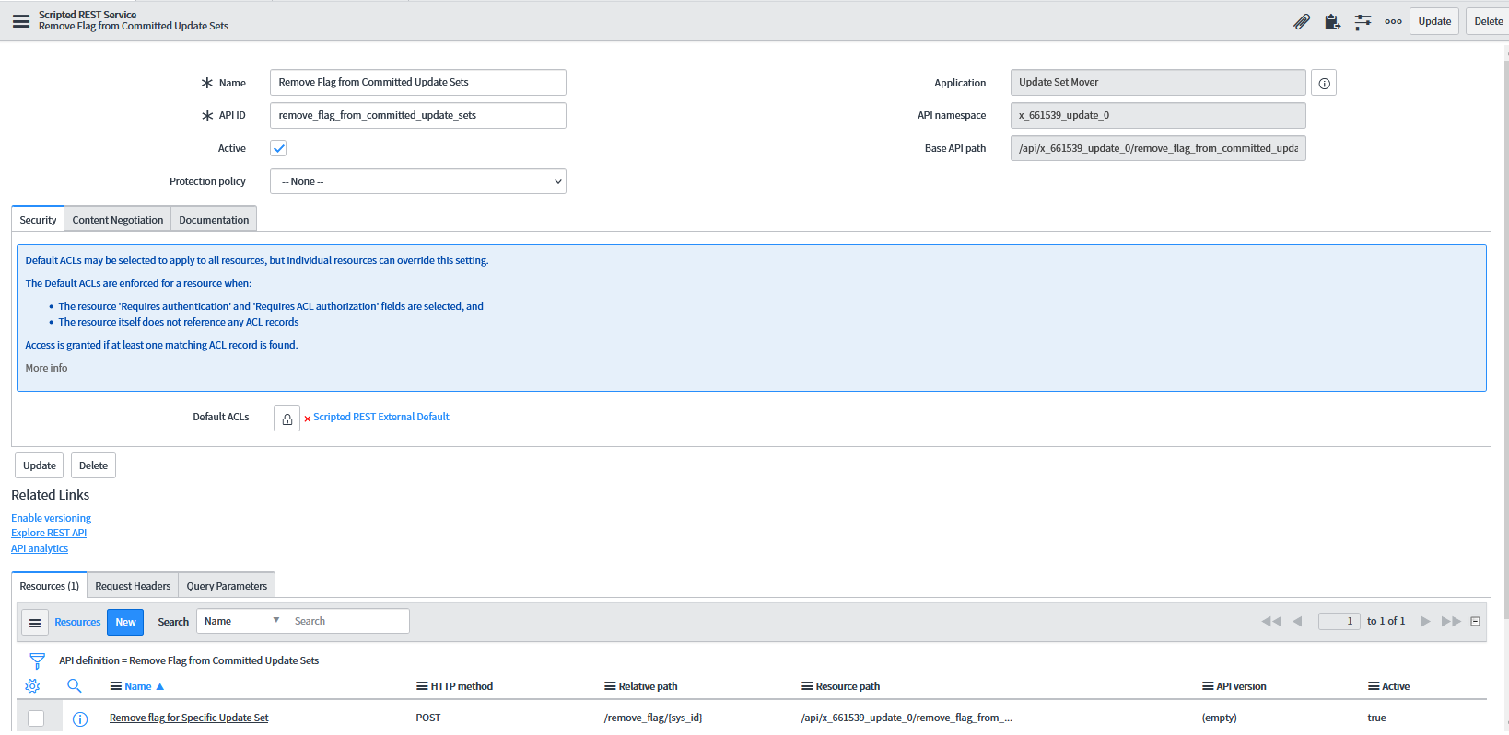

Scripted REST Resource
Script responsible to make the REST call to the previous instance and update the flag “Ready to move to prod?” to false and the flag “Completed on Prod” to true.

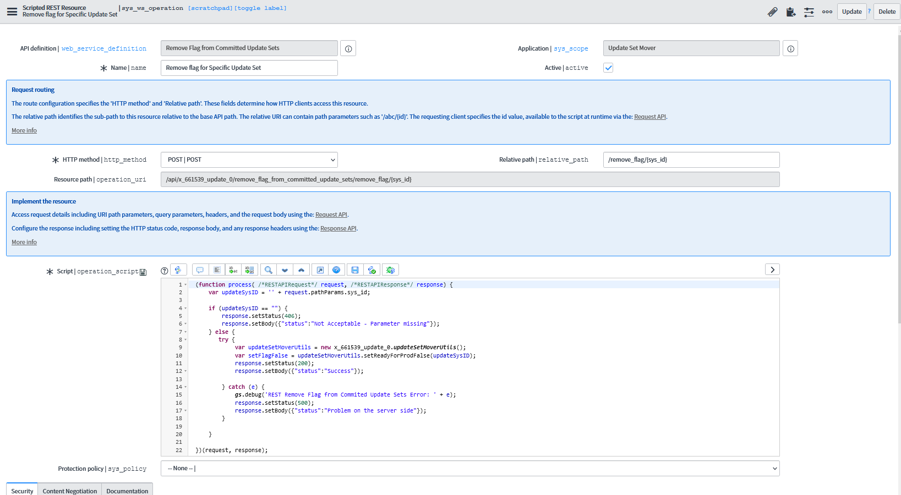


Select Information Classification | Uncontrolled if printed.
© Fujitsu 2022 | 7935. All rights reserved. Fujitsu and Fujitsu logo are trademarks of Fujitsu Limited registered in many jurisdictions worldwide. Other product, service and company names mentioned herein may be trademarks of Fujitsu or other companies. This document is current as of the initial date of publication and subject to be changed by Fujitsu without notice. This material is provided for information purposes only and Fujitsu assumes no liability related to its use.

